Volumetric Calculations
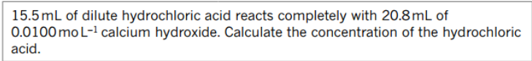

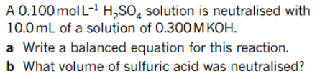
3.

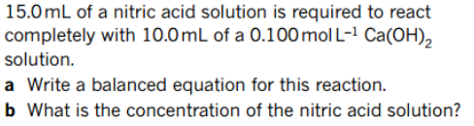
4.

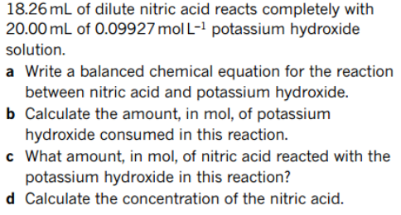
5.

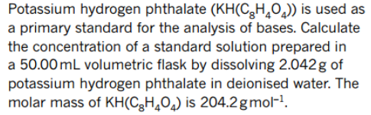
6.

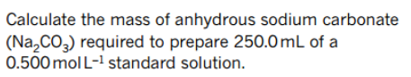
7.

8. 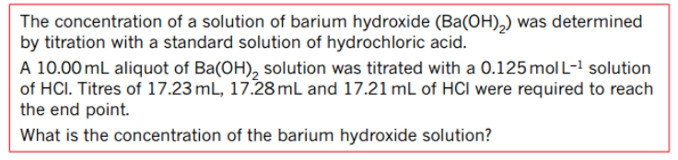

9.

10.

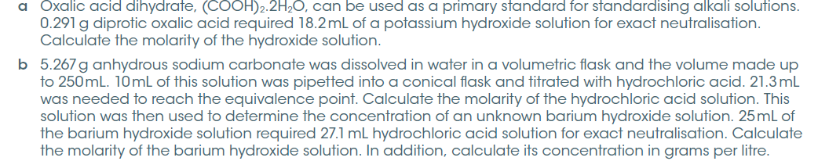

Titration Involving Dilution


 